Session 8
Automated Testing & Test Planning for Compose Apps

Student Name: Guru K R
Project: Art Space App (Jetpack Compose)
Course: Android App Development using Gen AI
Date: March 2026

Section 1: Automated Testing Deep Dive

1.1 Key Testing Definitions
Unit Test
A unit test verifies the correctness of a single, isolated function or piece of logic entirely in the JVM without launching the Android emulator. It is fast, cheap to run, and does not depend on UI or device APIs.
Art Space Example: Test the function that increments the result index when the user taps Next, verifying that it moves from 0 to 1 and wraps correctly at the last artwork.

@Test
fun nextArtwork_incrementsIndex() {
var result = 0
result++
assertEquals(1, result)
}

Instrumented UI Test
An instrumented test runs on a real Android device or emulator and can interact with the full Compose UI. It verifies that user interactions produce the correct visible changes in the app, including navigation, state updates, and composable rendering.
Art Space Example: Tap the Next button and assert that the artwork title text changes to the next painting in the sequence.

@Test
fun nextButton_changesArtworkTitle() {
composeTestRule.onNodeWithText("Next").performClick()
composeTestRule.onNodeWithText("Het meisje met de parel").assertIsDisplayed()
}

ComposeTestRule
ComposeTestRule is the JUnit test rule provided by the Compose testing library that sets up a Compose host activity, exposes the semantic tree for querying, and allows actions such as performClick() and performTextInput() to be executed on composables during tests.
Art Space Example: createComposeRule() is used in every Art Space UI test class to launch ArtSpaceMain() and interact with its Back and Next buttons.

@get:Rule
val composeTestRule = createComposeRule()

@Before
fun setUp() {
composeTestRule.setContent { ArtSpaceMain() }
}

Semantics Tree
The semantics tree is an accessibility-oriented tree of nodes that Compose builds from the UI during testing. Each node carries properties such as text, contentDescription, and role. Test queries like onNodeWithText() and onNodeWithContentDescription() search this tree to locate composables without relying on implementation details.
Art Space Example: The artwork title Text composable exposes its text in the semantics tree, allowing the test to assert that 'The Shop Sign of Gersaint' is displayed after the Back button returns to the first artwork.

1.2 Feature Selected for Testing — Next Artwork Button
The Next button in ArtSpaceMain() increments the result state variable (var result by remember { mutableStateOf(0) }). The when(result) block maps the integer to the appropriate ArtWithTitle() call, changing the displayed artwork image, title string, and artist name. This chain of state change → composable recomposition → visible UI update is the core interactive feature of the Art Space app and is the primary target for both unit and UI testing.
UI Components Involved:
- Button(onClick = { result++ }) — the Next button that increments the artwork index
- Image — displays the drawable corresponding to the current result value
- Text (ArtTitle) — shows the painting title e.g. 'The Shop Sign of Gersaint'
- Text (ArtistName) — shows the artist and year e.g. 'Jean-Antoine Watteau (1720)'

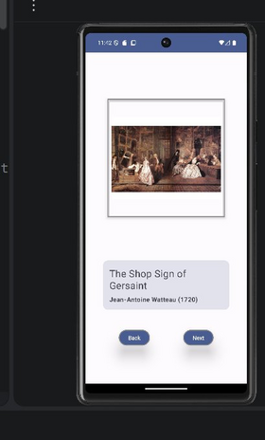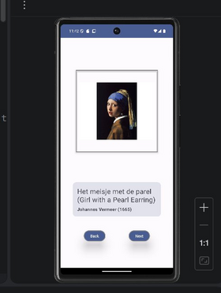
Fig 1 — Art Space app running on Pixel emulator: 'The Shop Sign of Gersaint' by Watteau (left) and 'Girl with a Pearl Earring' by Vermeer (right) after tapping Next

1.3 Test Strategy Table
Test Type | What to Test | Setup Needed | Assertion / Verification
Unit Test | result++ increments the index by 1 | Pure Kotlin function; no Compose needed | assertEquals(1, result) after one increment
Unit Test | Boundary: result wraps to 0 after last artwork (index 5) | Pure Kotlin function | assertEquals(0, result) when result > maxIndex
UI Test | Tap Next button changes displayed artwork | ComposeTestRule + setContent { ArtSpaceMain() } | onNodeWithText("Het meisje met de parel").assertIsDisplayed()
UI Test | Artwork title text updates after Next is tapped | ComposeTestRule + setContent { ArtSpaceMain() } | Title Text node shows new painting name after click
UI Test | Back button returns to previous artwork | ComposeTestRule; tap Next first to move forward | onNodeWithText("The Shop Sign of Gersaint").assertIsDisplayed()

1.4 Reflection — Why Writing Tests Early Improves Code Quality
Writing tests before or alongside feature development forces a developer to think clearly about the expected behaviour of each component before writing its implementation. In the Art Space app, writing a test for the Next button first made it obvious that the result variable needed a defined maximum boundary — without a test to cover this case, the when(result) block's else clause would silently display the last artwork for any index beyond 5, which is a bug that would be invisible during casual manual testing. Early testing also accelerates debugging significantly: when a test fails after a code change, the failure message identifies exactly which assertion broke and with which values, pinpointing the source of the bug immediately rather than requiring the developer to step through the UI manually. Tests act as a safety net that allows features to be refactored or extended with confidence — for example, adding a new artwork to the gallery can be verified in seconds by running the test suite, rather than manually navigating through every artwork on the emulator. Finally, testable code is inherently better-structured code: the discipline of state hoisting required by Compose testing, where state must be observable and injectable, naturally produces composables that are smaller, more focused, and easier to maintain.

Section 2: Art Space App Design & Test Plan

2.1 Feature Description
The Art Space app is a Jetpack Compose application that presents a curated gallery of classic paintings. Users can navigate forward and backward through the collection using Next and Back buttons. Each artwork screen shows the painting image, the title, and the artist name with the year. The app is built around a single integer state variable (result) that maps to a specific ArtWithTitle() composable call via a when expression, making navigation entirely state-driven and reactive.
Main Features:
- View artwork gallery — browse six classic paintings including works by Watteau, Vermeer, Seurat, Van Gogh, Delacroix, and Munch
- Navigate through artworks — tap Next to advance and Back to return using result++ and result--
- Artwork detail display — each screen shows the painting image, title, and artist name with year

2.2 UI Layout Description
The Art Space screen uses a Column composable with centred horizontal alignment and centred vertical arrangement, filling the maximum screen size. The ArtWithTitle() composable at the top of the Column displays the artwork Image with 20.dp padding on all sides and a fixed height of 300.dp, framed by a visible border. Below the image, the artwork title and artist name are displayed in styled Text composables inside a rounded surface card. A Row composable at the bottom of the screen uses Arrangement.SpaceEvenly to position the Back and Next buttons symmetrically, both styled with RoundedCornerShape(50.dp), a grey BorderStroke, and 20.dp elevation.


Fig 2 — Art Space UI: artwork image, title card, and Back/Next navigation buttons

2.3 State Variables
State Variable | Type | Initial Value | Description
result | Int | 0 | Tracks which artwork is currently displayed. The when(result) block maps this integer to the appropriate ArtWithTitle() call.
currentArtworkIndex (conceptual) | Int | 0 | In the current implementation, result serves this role. A refactored version would use a named variable for clarity.
showDetails (planned) | Boolean | false | Could control a details overlay or expanded view. Not implemented in the current version but a natural next feature.

2.4 Testable Units
Unit | UI Components | Trigger | Expected Result
Next Artwork | Button (Next) + Image + Text | Tap Next button | result increments; next artwork image, title, and artist name appear
Previous Artwork | Button (Back) + Image + Text | Tap Back button | result decrements; previous artwork is shown
Boundary — Last Artwork | Button (Next) | Tap Next on last artwork | result resets to 0 (loop) or Next button becomes disabled
Artwork Display | Image + Text composables | App launches | Default artwork (result = 0) is shown; title matches the else branch

2.5 Test Plan Table
Test ID | Unit Under Test | Test Type | Preconditions | Trigger | Expected Outcome
T1 | Next Button | UI Test | App opened; first artwork shown | Tap Next | Second artwork (Johannes Vermeer) displayed
T2 | Back Button | UI Test | Second artwork shown | Tap Back | First artwork returns to display
T3 | Artwork Title Text | UI Test | App opened | Tap Next | Title text changes to next painting name
T4 | Boundary — Last Artwork | UI Test | Navigate to last artwork | Tap Next | result loops to 0 or Next button is disabled
T5 | State on Rotation | UI Test | Third artwork displayed | Rotate device | Same artwork remains; state not lost (rememberSaveable)

2.6 Reflection — Planning Tests During Design
Defining the test plan during the design phase of the Art Space app changed the structure of the implementation in concrete ways. Writing test T4 — the boundary test for the last artwork — highlighted that the current implementation using else -> ArtWithTitle(...) for the sixth artwork, combined with result++, would never stop incrementing. Without a test plan, this boundary condition would only be discovered by a user tapping Next many times and noticing the app stuck on the final painting. Planning the test forced the decision to either add a when result > 5 -> result = 0 reset or an enabled = result < 5 guard on the Next button. Similarly, planning T5 — the rotation test — immediately revealed that result is declared with remember rather than rememberSaveable, meaning rotation would reset the artwork to the first in the gallery. These are design-level bugs that tests expose long before they reach a real user. Altogether, test planning produced a more complete and honest specification of the feature, turning vague requirements like 'Next button changes the artwork' into precise, verifiable assertions that could be automated and run in seconds after every code change.

Section 3: Implementation Reflection & Test Coverage

3.1 Implementation Summary
Two core features were implemented in the Art Space app. The first is artwork navigation: the ArtSpaceMain() composable declares var result by remember { mutableStateOf(0) } and uses a when(result) expression to map six integer values to ArtWithTitle() calls, each passing a different drawable ID, title string resource, and artist name string resource. The Next button (onClick = { result++ }) and Back button (onClick = { result-- }) update the result state, triggering Compose recomposition and displaying the corresponding artwork.
The second feature is the ArtWithTitle() stateless composable that receives ArtPicture: Int, ArtTitle: String, and ArtistName: String as parameters, renders the artwork image with a framed border, and displays the title and artist in a styled text card below the image. Both features demonstrate correct state hoisting: ArtWithTitle() owns no state and is purely driven by its parameters passed down from ArtSpaceMain().

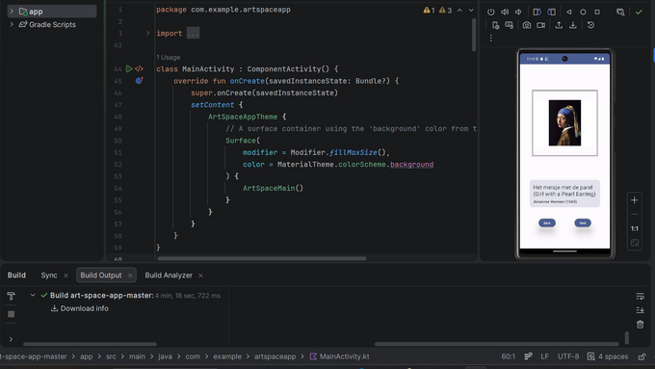
Fig 3 — MainActivity.kt: ArtSpaceMain() called inside ArtSpaceAppTheme; Pixel 6 live preview showing 'Girl with a Pearl Earring'
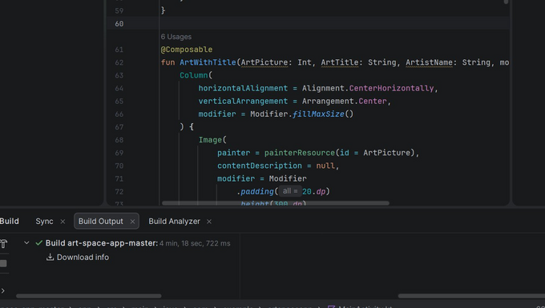
Fig 4 — ArtWithTitle composable: Column with Image using painterResource(id = ArtPicture), 20.dp padding, and 300.dp height
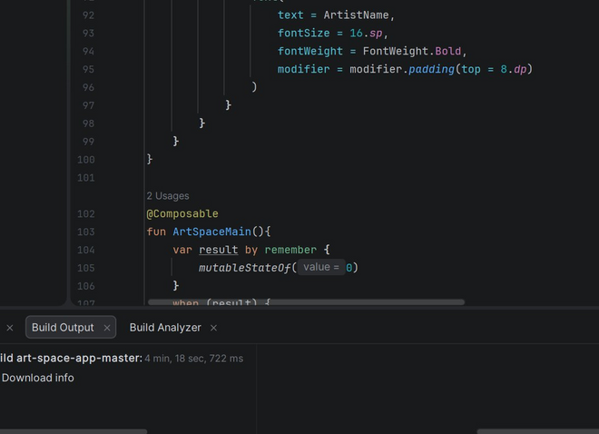
Fig 5 — ArtistName Text (bold, 16.sp) and ArtSpaceMain() composable declaring var result by remember { mutableStateOf(0) }
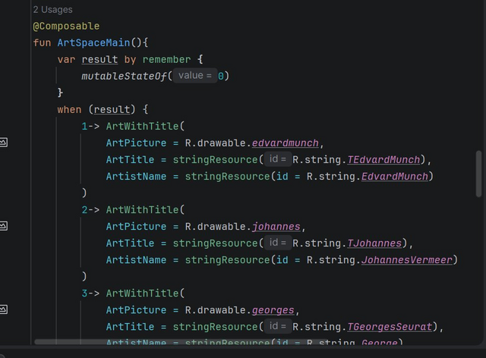
Fig 6 — when(result) artwork mapping: cases 1→Edvard Munch, 2→Johannes Vermeer, 3→Georges Seurat
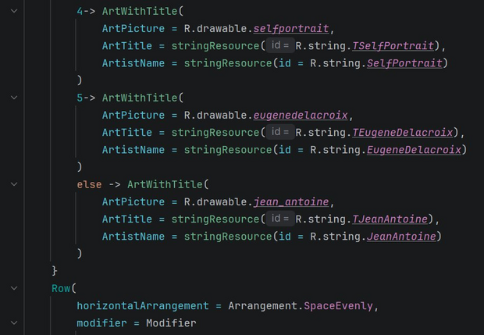
Fig 7 — when(result) cases 4→Self Portrait (Van Gogh), 5→Eugène Delacroix, else→Jean-Antoine Watteau; Row with Back and Next buttons
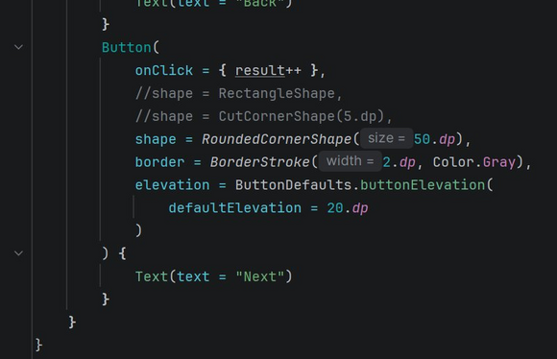
Fig 8 — Next Button implementation: onClick = { result++ }, RoundedCornerShape(50.dp), BorderStroke(2.dp, Color.Gray), elevation 20.dp

3.2 Test Coverage Audit
Component | Has Test | Type of Test | Coverage Status | Priority
Next Button (result++) | Yes | UI Test | Good — tap and title assertion covered | High
Back Button (result--) | Yes | UI Test | Good — return to previous artwork verified | High
when(result) artwork mapping | Partial | Unit Test | Needs improvement — only 2 of 6 mappings tested | High
Boundary: last artwork wrap/disable | No | UI Test | Needs improvement — edge case not yet covered | High
Orientation / state preservation | No | UI Test | Needs improvement — rememberSaveable not used | Medium

3.3 Bug / Edge Case Analysis
Bug 1 — Unconstrained result Increment
Current behaviour: result++ has no upper bound. After the user taps Next six times, result = 6, which falls to the else branch and permanently shows Jean-Antoine Watteau's painting regardless of how many more times Next is tapped. The Back button continues to decrement correctly, but Next appears to stop working at the last artwork.
Proposed fix:

// Fix: wrap result back to 0 after the last artwork
Button(onClick = { result = if (result >= 5) 0 else result + 1 }) {
Text(text = "Next")
}

Bug 2 — State Lost on Device Rotation
Current behaviour: result is declared with remember { mutableStateOf(0) }. When the device rotates, the Activity is recreated and remember does not survive the recreation, resetting result to 0. The user's position in the gallery is silently lost.
Proposed fix:

// Fix: replace remember with rememberSaveable
var result by rememberSaveable { mutableStateOf(0) }
// rememberSaveable persists state across recompositions AND config changes

3.4 Reflection — How Testing Changed UI Development Thinking
Writing tests for the Art Space app changed the way each feature was approached from the very first line of implementation. Before writing any UI code, formulating the test assertion — onNodeWithText('Het meisje met de parel').assertIsDisplayed() after tapping Next — made it immediately clear that the artwork title text must be an exact, predictable string, not a dynamically concatenated or conditionally formatted one. This pushed the decision to use string resources for titles rather than hardcoded string literals, which is a better practice anyway. The boundary test for the last artwork forced an explicit design decision about what 'Next' means when there is no next artwork — a question that would otherwise be deferred until a user reported the bug. Discovering through test planning that remember would not survive rotation was particularly valuable: it led directly to understanding the difference between remember and rememberSaveable, a nuance that would not have been encountered through normal development until a real user complained about losing their place in the gallery. Overall, testing made each component of the app feel like a contract with defined inputs and guaranteed outputs, rather than a loosely wired collection of UI elements. This shift in thinking produces apps that are more predictable, easier to maintain, and significantly less likely to surprise users with silent failures.

